Experiment 1: Basic Image Handling and Processing
Aim
To read an image using Python and convert the image into gray-scale.
Procedure
- Import the OpenCV library.
- Read the input image using cv2.imread().
- Display the original image.
- Convert the image to gray-scale using cv2.cvtColor().
- Display the gray-scale image.
- Close the image windows.

Code
import cv2
image = cv2.imread("sample.jpg")
cv2.imshow("Original Image", image)
gray_image = cv2.cvtColor(image, cv2.COLOR_BGR2GRAY)
cv2.imshow("Grayscale Image", gray_image)
cv2.waitKey(0)
cv2.destroyAllWindows()

Input
A color image (sample.jpg).

Output
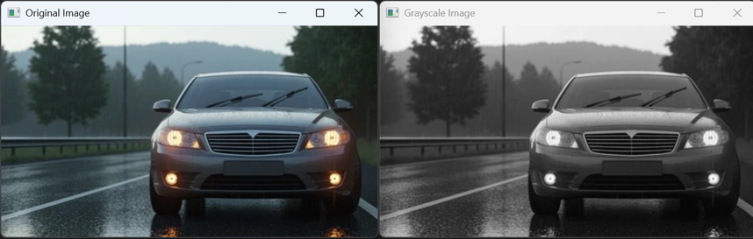
The original color image and its converted gray-scale image are displayed.

Result
The given color image was successfully read and converted into a gray-scale image using Python and OpenCV.

